31.03. – 04.04.2025

HANNOVER, GERMANY

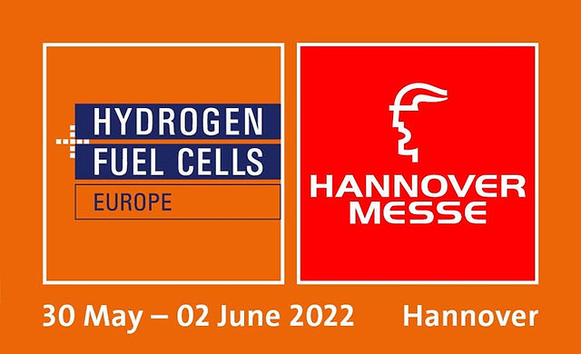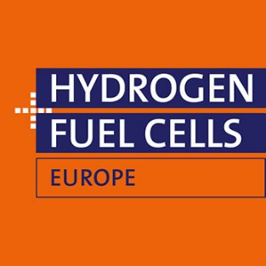

NORWEGIAN PAVILION

Application Form

|  |  |
| --- | --- |
| Company | Click or tap here to enter text. |
| Address | Click or tap here to enter text. |
|  | Click or tap here to enter text. |
|  | Click or tap here to enter text. |
| Contact Person | Click or tap here to enter text. |
| Phone (contact) | Click or tap here to enter text. |
| Mail (contact) | Click or tap here to enter text. |
| Mail (invoice) | Click or tap here to enter text. |
| Internet | Click or tap here to enter text. |

We hereby request Click or tap here to enter text. (No. of stand units/approximately **5 sqm**).

Price per unit: NOK 144 000 + MVA (NOK 140 000 until 31st October 2024).

We hereby request Click or tap here to enter text. (No. of stand units/approximately **10 sqm**).

Price per unit: NOK 200 000 + MVA (NOK 195 000 until 31st October 2024).

We hereby request Click or tap here to enter text. (No. of stand units/approximately **15 sqm**).

Price per unit: NOK 247 000 + MVA (NOK 240 000 until 31st October 2024).

PLEASE NOTE THE WE WILL ALLOCATE STANDS ON A FIRST COME, FIRST SERVE BASIS!

Other remarks:

Click or tap here to enter text.

We accept the NORWEGIAN PAVILION terms and conditions.

We agree to receive relevant information concerning the NORWEGIAN PAVILION at Hannover Messe 2025  
 on the e-mail address given above.

Place, date Signature

Please return the application form to: E-mail: [sh@handelskammer.no](mailto:sh@handelskammer.no?subject=Hannover%20Messe%202025_application)

31.03. – 04.04.2025

HANNOVER, GERMANY



**Norwegian Pavilion**

Organiser

Deutsch-Norwegische Handelskammer Services AS (AHK)

Drammensveien 111 B   
0273 Oslo / Norwegen

Project manager: Susanne Hawkins   
Phone: +47 22 12 82 31  
E-mail: sh@handelskammer.no

The NORWEGIAN PAVILION Hydrogen + Fuel Cells at Hannover Messe 2025 is the place where you will meet existing and potential new clients gathering together to discuss the industry needs. The Pavilion will be paced in hall 13 as vital part of the joint presentation of more than 500 exhibitors from the hydrogen value chain.

For the coming edition we can offer you again an improved design and concept. While maintaining a high-livel quality, this will accomodate our common responsibility in terms of sustainability. Our pavilion design guidelines will provide a strong presentation of the Norwegian hydrogen industry.

Services included

**Specific for the three stand types**

**Stand type C: 15 m2**

* 2 walls for graphic print
* 55” Display
* 2 counters
* 3 bar chairs

**Stand type B: 10 m2**

* 2 walls for graphic print
* 42” Display
* 1 counter
* 2 bar chairs

**Stand type A: 5 m2**

* 1 walls for graphic print
* 32” Display
* 1 counter
* 1 bar chair

On request, stands of all types can be combined. Please specify in the comments above.

**Common for all stand types**

* Exhibition space in the Hydrogen + Fuel Cells Europe Community at Hannover Messe
* Speaking opportunity in one of the forums of Hydrogen + Fuel Cells Europe
* Promotion as exhibitor of the Hydrogen + Fuel Cells Europe on the website & social media campaigns
* Participate in B2B events, networking functions & seminars
* High quality & sustainable stand construction
* Floor covering, general lighting, electrical outlet, Wi-Fi, cleaning and waste disposal
* Dedicated project manager to assist prior to and onsite at the fair
* Access to the lounge with breakfast, lunch and refreshments throughout the day
* Access to co-working spaces, private meeting rooms and storage rooms
* Catalogue entry in publication of trade fair organizer, in general and on Norway landing page

Alterations to general stand design, additional equipment such as bigger TV screen, print of graphics and other profiling items etc. will be charged individually.

31.03. – 04.04.2025

HANNOVER, GERMANY



**Terms & Conditions**

1. Registration   
Registrations will be registered by date and time of receipt and will be confirmed by email with a binding effect.

2. Terms of Payment

When registrating, 30% of the participation fee is to be paid as deposit. The rest of the participation fee (70%) will be invoiced in November 2024. After completion of the event, exhibitors will receive a final invoice of individually incurred costs not covered by the standard package. All invoices are due in 21 days of the invoice date, unless agreed otherwise.

3. Cancellation

In case the show is postponed by the organiser and the exhibitor does not want to participate on the new dates, 100% of the participation fee will be refunded.

After 15th November 2024 no refund is granted in case of cancellation for any other reason.

4. Stand Allocation   
Please note that stand space will be allocated on a first come, first serve basis. In case that several exhibitors are interested in one particular stand, the allocation will be determined by time and date of the incoming application. We reserve the right to make adjustments in size, dimensions, stand design or allocation of exhibitors. Exhibitors will always be informed about changes as soon as possible.

5. Obligations of Deutsch-Norwegische Handelskammer Services AS (AHK)  
AHK is committed to arrange the event as described in the registration form, provided a sufficient number of participants. In the case of an insufficient number of participants or significant changes in external preconditions, DNHKS can dissolve this contract. In this case, information will be given to participants as early as possible. Paid registration fees will be refunded.

6. Force Majeure   
AHK is not accountable if the project fails due to circumstances that are beyond the control of AHK, such as: strikes, natural disasters, lockout, changes in legislation, lockdowns due to a pandemic, or similar. If, due to the above mentioned conditions, the project cannot take place, the registered participants are liable for the costs incurred, including project management.

7. Disagreements   
If disagreements arise connected to this project, the legal department of AHK will try to resolve the dispute. Should this not lead to success, the parties will authorize the Oslo City Court for a judicial resolution of the dispute