

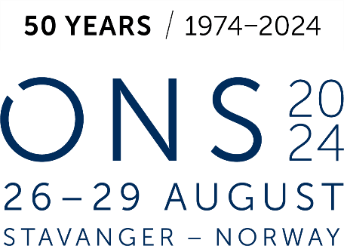

GERMAN PAVILION

Application Form
Company | Click or tap here to enter text.
Address | Click or tap here to enter text.
 | Click or tap here to enter text.
 | Click or tap here to enter text.
Contact person | Click or tap here to enter text.
Phone (contact) | Click or tap here to enter text.
E-Mail (contact) | Click or tap here to enter text.
Further contact person (name + E-Mail) | Click or tap here to enter text.
E-Mail (invoice) | Click or tap here to enter text.
Reference on invoice | Click or tap here to enter text.
Internet | Click or tap here to enter text.

We hereby order stand number : Click or tap here to enter text. 1th priority
Click or tap here to enter text. 2nd priority

PLEASE NOTE THE WE WILL ALLOCATE STANDS ON A FIRST COME, FIRST SERVE BASIS!
Other remarks:
Click or tap here to enter text.
☐ We accept the GERMAN PAVILION terms and conditions.
☐ We agree to receive relevant information concerning the GERMAN PAVILION at Nor-Shipping 2027
on the e-mail address given above.
Click or tap here to enter text.
Place, date Signature
Please return the application form to:
E-mail: sh@handelskammer.no

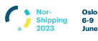

German Pavilion
Organiser
Deutsch-Norwegische Handelskammer Services AS (DNHKS)
Drammensveien 111 B
0273 Oslo / Norwegen
Susanne Hawkins
+47 22 12 82 31
sh@handelskammer.no
Project manager:
Phone:
E-mail:

The GERMAN PAVILION at Nor-Shipping 2027 is the place where you will meet existing and potential new clients gathering together to discuss the industry needs. For the coming edition we can offer you again an improved design and concept based on system with largely reusable parts. While maintaining a high-livel quality, this will accomodate our common responsibility in terms of sustainability. Our pavilion design guidelines will provide a strong presentation of the German energy industry.

Services Included
- Catalogue entry in publication of trade fair organiser
- German branded stand design to draw visitors to the pavilion
- Dedicated project manager and team to assist prior to and onsite at the show
- Pavilion lounge with light lunch and refreshments throughout the day
- General information desk manned at all time during the exhibition period
- Prime location at the show
- Promotion of the pavilion through various activities prior to the exhibition
- 1 year of membership at the German Norwegian Chamber of Commerce (01.01.2027 – 31.12.2027)*
- Turnkey stand design & construction
- Uniform floor covering (dark carpet)
- White textile walls (print as surcharge)
- General lighting, 1 electrical outlet, basic cleaning of your booth before and during the fair
- 1 counter, 1 bar table, 2 bar chairs, 1 waste basket
- Free registration and free listing of sub-exhibitors
As always, we will strive to make your stay with us as comfortable and rewarding as possible, providing opportunities to generate new businesses and strengthen your existing commercial and social ties.

All additional equipment such as furniture, wall print, shelves, extra profiling items, etc. will be charged separately.

*If you have not been a member before.




Terms & Conditions

1. Registration
The registration will be confirmed in writing with a binding effect. Stands will be sold on a first come, first serve basis. In case that several exhibitors are interested in one particular stand, the allocation will be determined by time and date of the incoming application.

2. Terms of Payment
When registrating, 30% of the participation fee is to be paid as deposit. The rest of the participation fee (70%) will be invoiced in January 2027. After completion of the event, exhibitors will receive a final invoice of individually incurred costs not covered by the standard package. All invoices are due in 21 days of the invoice date, unless agreed otherwise.
3. Cancellation
Free cancellation up to 30th September 2026. You will receive back the deposit, or the participation fee paid until then.
In case the show is postponed by the organiser and the exhibitor does not want to participate on the new dates, 100% of the participation fee will be refunded.
After 30th September 2026 no refund is granted in case of cancellation for any other reason.
4. Stand Allocation
Please specify preferred stand number. In case of lack of space or if you register after the deadline, DNHKS reserves the rights to find another suitable location within the pavilion. We reserve also the right to make slight adjustments in size and dimensions, if necessary. The exhibitors will always be informed about the changes.
5. Obligations of Deutsch-Norwegische Handelskammer Services AS
DNHKS is committed to arrange the event as described in the registration form, provided a sufficient number of participants. In the case of an insufficient number of participants or significant changes in external preconditions, DNHKS can dissolve this contract. In this case, information will be given to participants as early as possible. Paid registration fees will be refunded.
6. Force Majeure
DNHKS is not accountable if the project fails due to circumstances that are beyond the control of DNHKS, such as: strikes, natural disasters, lockout, changes in legislation, or similar. If, due to the above mentioned conditions, the project cannot take place, the registered participants are liable for the costs incurred, including project management.
7. Disagreements
If disagreements arise connected to this project, the legal department of DNHKS will try to resolve the dispute. Should this not lead to success, the parties will authorize the Oslo City Court for a judicial resolution of the dispute.

